Drs Winn Parkinson Gavin and Haddad
The Rockwell and Wrose Practice
www.rockwellandwrosepractice.nhs.uk



Patient Participation Directed Enhanced Service Report
2013 - 2014

Executive Summary

The Rockwell and Wrose Practice has embraced the patient engagement culture and generated a proactive and committed patient group who work with us to improve performance, patient safety and service delivery.

The patient group is not exclusive and open to registered patients (and carers) providing a forum to learn, contribute to discussions or feedback without prejudice

The Action Plan set during 2012 - 2013 has been achieved to the satisfaction of the practice and patient group beyond all expectations.

Rockwell and Wrose practice ensure their patient group has access to practice data relating to performance, activity and finance in an attempt to provide basic education and information about fundamental NHS systems and primary care functions.

A sub group of Patient Representatives take a more proactive role, representing Rockwell and Wrose Practice at Patient Network meetings and managing the suggestion box at both branches.

Index

Page

Executive Summary 1

Index 2

Introduction 3

Priority Areas defined (and Minutes) 2012 4

Patient Group Profile 5

Actions to Ensure Patient Group Representative 6

Access arrangements 7

Achievements against Action Plan 2012 – 2013 8

Patient Survey Results 2013 9

“New” Action Plan for 2014 - 2015 9

Steps outlining how Action Plan can be achieved 9

Conclusion 10

Introduction

The Rockwell and Wrose Practice is a PMS practice with a serving 9445 patients in North Bradford locality; BD2, BD10 and BD18. The patient list size has risen by 115 patients since 2012 – 2013 report.

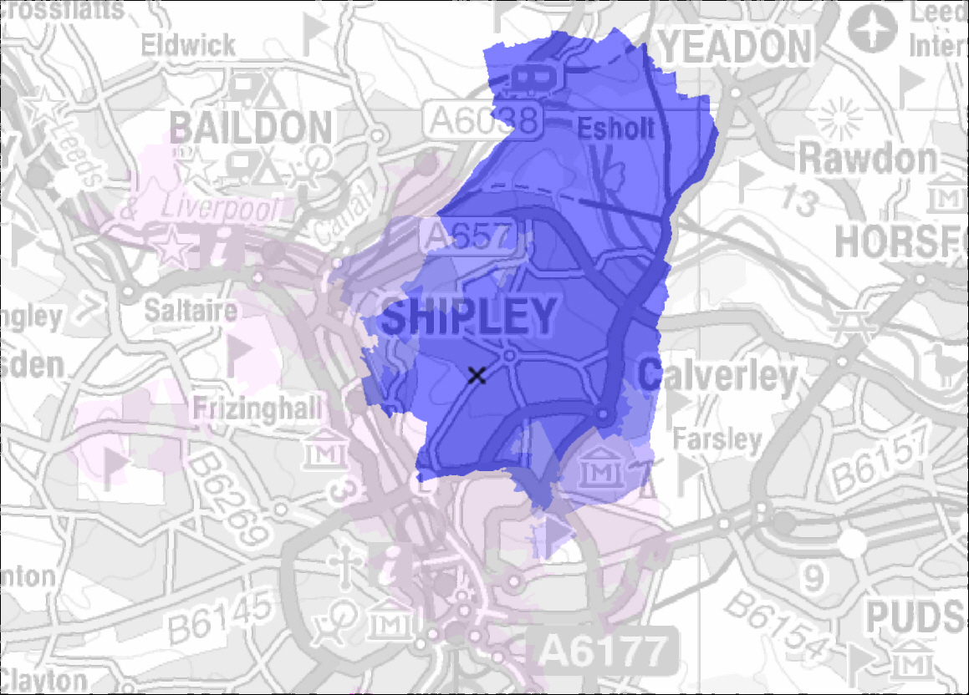

The Rockwell and Wrose Practice operates two fully functioning branch sites approximately 1 ½ miles apart;

- Wrose Health Centre Kings Road Bradford BD2 1QG
- Rockwell Medical Centre, 2 Summerfield Road, Thorpe Edge, Bradford, BD2 1QG

B83064 Team members actively involved with Patient Involvement Group

Dr Richard Haddad GP Lead ( clinical)
Dr A Gavin GP
Rachel Thompson Chair, Lead and Practice Manager
Donna Ford Scribe and Supporting Manager
Alison Kaye Practice Nurse Representative
Jeanette Armistead Receptionist Rep Rockwell
Helen Pitts Receptionist Rep Wrose
Ian Andrews Case Manager

Patient Representation Group 2013 - 2014

The Rockwell and Wrose Practice has established a patient group of approximately 35 patients (see table on page 3)

Patient Meetings held quarterly, lead by Dr Richard Haddad/ Dr Alice Gavin and chaired by Mrs Rachel Thompson (Practice Manager).

Patient Group Meeting Dates 2013 – 2014

*minutes on website www.rockwellandwrosepractice.nhs.uk

Monday 15th April 2013
Monday 10th June 2013
Friday 23rd August 2013 Patient Rep Group only
Monday 9th September 2013
Monday 20th January 2014

Each meeting has an Open Forum section to raise compliments, criticism or complaints. There is also an opportunity for patients to reflect upon service provision and to feedback views.

Priority areas identified by patients for 2013 – 2014

Improve the Seating the Waiting Room – introduce high back chairs with arms
Supply disinfectant Gel in Waiting Room
During Hot weather – offer patients a drink of water
Review the DNA policy

Regular Patient Participation Group Profile 2013 2014

♀  Male | Age | Profile | Ethnicity | ♂  Female | Age | Profile | Ethnicity
1 | 69 | Retired Disabled  Wrose | White British | 11 | 79 | Blind, Retired  Rockwell | White British
2 | 73 | Retired  Rockwell | White British | 12 | 77 | Volunteer  Wrose | White British
3 | 66 | Retired MH Nurse  Wrose | White British | 13 | 64 | Retired  Wrose | White British
4 | 69 | Retired Policeman  Wrose | White British | 14 | 69 | Retired  Wrose | White European
5 | 68 | Carer  Wrose | White British | 15 | 67 | Retired Disabled  Wrose | White British
6 | 83 | Retired Journalist  Wrose | White British | 16 | 79 | Retired  Wrose | White British
7 | 73 | Retired Disabled  Wrose | White British | 17 | 76 | School Volunteer  Wrose | White British
8 | 76 | Retired  Wrose | White British | 18 | 80 | Retired  Wrose | White British
9 | 88 | Retired  Wrose | White European | 19 | 82 | Retired  Wrose | White British
10 | 66 | Retired Butcher  Wrose | White British | 20 | 54 | Employed /Carer  Wrose | White British
11 | 67 | Retired  Wrose | White British | 21 | 55 | Retired Police  Wrose | White British
12 | 65 | Employed  Wrose | White British | 22 | 63 | Retired  Wrose | White British
13 | 69 | Retired  Rockwell | White British | 23 | 823 | Retired  Wrose | White British
14 | 51 | Employed  Rockwell | White British | 24 | 79 | Retired  Wrose | White British
 |  |  |  | 25 | 69 | Retired  Rockwell | White British

Average age of male participants 70 years
Average age of female participants 63.5 years
Wrose Attend Wrose Branch
Rockwell Attend Rockwell Branch

Actions taken to ensure patient group is representative.

The patient representatives identified that the following patients groups lack sufficient representation in the PPG.

- Patients aged under 65
- Ethnic Backgrounds

Throughout 2013 – 2014 the PPG have worked with the practice to increase participation from under represented patient groups with the following outcomes; (minutes on practice website)

Criteria Group | Suggestions from PPG & practice staff | Actions | Outcomes
Patients < 65 | 2 PRG volunteers to attend baby clinic and speak to parents | Completed | Positive feedback on survey sheets, however parents not able to attend meetings.
Patients < 65 | Contact local Upper Schools to offer to talk to 6th formers | Email and follow up letter sent Sept and Oct 2013 | Nil Response Not successful.
Ethnicity | Staff and PRG canvas ethnic patients to attend PPG. | Message placed patient call board. Personal invites ethnic origins  Our ethnic patient representative to canvass more support from local community | Ongoing

Patient Access

The Rockwell and Wrose Practice is open between the hours of 8.00 am until 6.30 pm Monday to Friday and has excellent access arrangements.

Patients can walk in, telephone or use their computer to communicate with the surgery ( via practice website) to make arrangements to be seen.

There are a number of access options

- Daily telephone triage for same day appointments
- Advanced booking for appointments with any doctor (face to face ) up to 4 weeks ahead
- Late Evening advanced booked appointments every Monday between 6.30 pm - 8.30 pm. These can be made by telephone , on line or over the reception counter.
- Telephone appointments – the chance to speak to any doctor for advice or clinical management.
- On Line booking ( via website with password )
- Home Visits can be arranged for patients with complex needs, poor mobility or palliative care
- Case Manager service ( home visits) for patients multiple co morbidity
- Nurse Appointments/HCA appointments

Outside core hours patients are advised ( by voicemail) to contact NHS 111.

ACHIEVEMENT AGAINST THE PREVIOUS ACTION PLAN
2012 - 2013

Outcome: increase Number of Telephone appts Achieved

Triage introduced November 2012 has solved this.

Outcome: Inform Patients if doctors are running late Achieved

Rockwell and Wrose Practice are able to demonstrate that average waiting time is 10 minutes for doctors and 10 minutes for nurses which is well within the tolerance level indicated in the first annual patient survey in 2011..

Outcome: Provide leaflets in larger font Measure introduced

Wherever possible the practice will supply leaflets in big font.

Outcome: SMS text Reminders for appts Achieved

Doctors, Reception Staff and PPG have promoted the use of SMS for patients which has increased from 5 % to 23.4 % patients now have access to SMS texts . This is an ongoing action.

Outcome: Allow telephone for script in Winter Partially Achieved

Done on a case by case basis.

Outcome: Increase number of Rockwell Patients on PPPG Achieved

-------------------------

Patient Survey October 2013 Results
Outcome of Survey 2013

Excellent Results and all PPG noted that all the lower scoring questions had been addressed in previous Action Plan for 2012 – 2013.

“New” Action Plan agreed with Patient Representative Group
for 2014 - 2015

Available to view on practice website February 2014

How the Action Plan will be implemented

Action | How | When
Improve the Seating the Waiting Room – introduce high back chairs with arms | Purchase more comfortable seating | Before march 2015
Supply disinfectant Gel in Waiting Room | Provide disinfection gel in waiting room | done
During Hot weather – offer patients a drink of water | Notice in waiting room offering dinks of water | done
Review the DNA policy | Audit DNA policy for number of patients removed | Before march 2015

CONCLUSION.

2013 – 2014 has been a successful and rewarding year for Rockwell and Wrose Practice and their patient group.

Both practice and patients have learnt a considerable amount of knowledge and information which has been used in a constructive way to broaden the patient’s experience and improve the quality of service.

The patient group has been given access to practice data and performance quality markers to explain the complex business of General Practice and generate greater interest in practice matters.

The patient voice is now embedded into the practice culture and ethos and we look forward to joint working possibilities in the future

.

