Request medication and book appointments with our new online service.
SystmOnline is available 24 hours a day, 365 days a year.
SystmOnline makes medication requests and appointments booking easy – any time.

With SystmOnline you are able to : view your medication and request repeat prescriptions, view and book appointments and view your medical records.

Not everyone can access their GP surgery during normal opening hours. SystmOnline helps by letting you request repeat medication and book appointments over the internet.

To be able to use this service you need to attend the surgery with photographic ID and proof of your address. The receptionist will then generate a unique password for you and you will be able to start using the SystmOnline service one hour later.

Manage your medication online

If you find it difficult to get to the surgery to order your next repeat prescription SystmOnline could male your life easier. Simply log onto SystmOnline and view a list of the medication you have been prescribed. Select the item you require and click the “request medication button”. You then collect your prescription as normal two days later after 1.00pm.

Checking and booking appointments online.

You are now able to book doctor’s appointments online as well as check the time of your appointments already booked. Log on to SystmOnline and click either “ future appointments “ which will show a list of appointments already booked for you or “book an appointment”, from there you will find the required day and available doctors and click on view available appointments. This then shows the selected information and you click on the appointment you require. That’s it – appointment booked.

On Line Access to Medical Records

You are now able to view your computerised medical records. Log onto SystmOnline and this will show you a list of options to view including “my detailed medical record” and “child vaccinations and immunisations” and also “pathology results”. Assuring medical record confidentiality is paramount therefore when you enter this for the first time, a message will be sent to the surgery to flag that you would like to be granted access. The surgery will contact you to sign a form confirming that you understand that allowing any third party your password and log in details will breach NHS code of confidentiality.

Security

The SystmOnline service has been developed, tested and accredited by a government body called NHS Connecting for health. All personal information used by SystmOnline is secure and protected. It is only available to staff at your practice who have the appropriate security controls, i.e those managing repeat prescriptions and appointments.

HINTS AND TIPS FOR SYSTMONLINE
Passwords
You are advised to change your password when you use SystmOnline for the first time.

Your password must be at least 8 Characters long and contain one number and one non-alphanumeric Character, e.g password5% or 2opensesame!

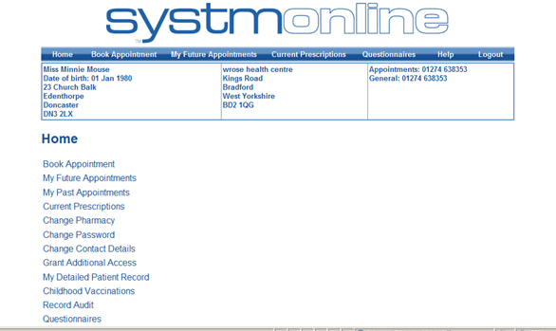

Trouble Logging On?

Have you typed the correct address into the address bar?
Either www.rockwellandwrosepractice.nhs.uk and choosing the “order repeat prescription” or “book an appointment “options or https://Systmonline.tpp-uk.com, the log in screen will appear using either of these.

You will not be able to log in until 1 hour after we have allocated a password and username.

Make sure that you are using the correct password – keep a record of it in a safe place.

