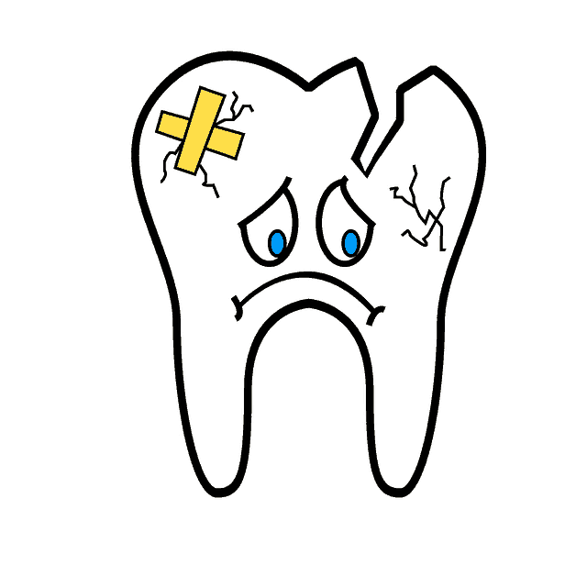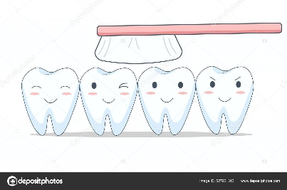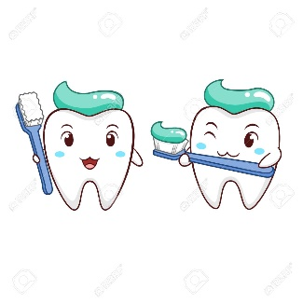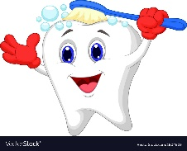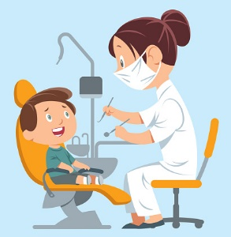

1. Make it a priority is to register with a dentist to ensure good long term oral health. Go to the NHS Choices website and search for ‘services near me’, then select ‘dentist’. This will give you a list of any dentists that are accepting new NHS patients in your area. If you are prepared to travel, you can usually find a suitable dentist. You can also ring round local dentists as sometimes the website may not be up to date and some dentist may open their NHS waiting lists for short periods without making this known on the website.
2. You can contact Westbourne Green Health Centre dental reception line on 01274 202463. Dental students from Leeds University undertake clinics there periodically and may be able to offer a course of treatment for those who don’t have a registered dentist.
3. If you are in pain or have any facial swelling, ring 111 to access the emergency dental service. They will take down your information and if necessary, offer you an appointment at an emergency dental centre.
4. There is a salaried dental service that provides care for people with special needs. They have strict referral criteria that patients should meet, some of which are listed below. Their contact number is 01274 251838.

(Learning difficulties, medically compromised, severely physically or mentally disabled, chronic mental health conditions, substance misusers, homeless people, refugees & asylum seekers.)

***REMEMBER- Prevention is the best cure.***

**Brushing your teeth twice a day and cleaning the interdental areas will help improve your oral health. Minimising your intake of sugary food and drinks will reduce the risk of decay and further dental problems. Children must be supervised with brushing and diet until the age of 14. You only get 1 set of adult teeth so make sure to look after them!**

**DON’T FORGET- No replacement is as good as your own natural teeth.**

*Your options if you have toothache & are not registered with an NHS dentist*