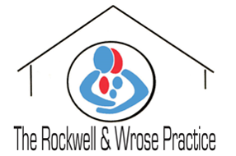
Private Fees 2022
Some services fall outside the doctors NHS obligations and therefore a charge will be payable. Charges are reviewed annually.
Medical Examination and Reports
Full Medical – including HGV/PSV Pilots & Guns £100
New – Additional licence within same appointment £50
Power of Attorney/ Mental capacity certification £100

Access to medical records - first request since May 2018 Free
Subsequent requests within 2 years dependent upon volume.

Insurance services

Insurance forms (BUPA ect) £30
Private sick note £13
Simple insurance form (less than 10 mins) £15

General letters to support medical claims.

Routine letter (patient must complete proforma) £15 upfront

Private patients

GP Consultations £40
Nurse Consultation £20
GP Domiciliary Visit £70

Pathology Fees Invoiced to private hospital

Immunisations

ACW Meningitis (including certificate) £50
Rabies (course of 3) £125
HEP B (course of 3 – travel only) £90

Methods of payment

Payment upon collection/ or at consultation. Cash or cheque acceptable (payable to The Rockwell and Wrose Practice). Receipt will be provided.

