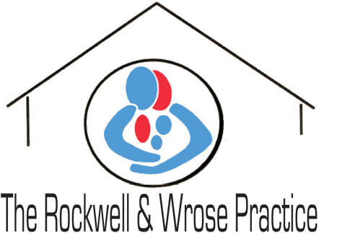
DRS GAVIN MILLS AND KENNEDY

How we use your medical records
Important information for Patients

- This practice handles medical records in-line with laws on data protection and confidentiality.

- We share medical records with those who are involved in providing you with care and treatment.

- In some circumstances we will also share medical records for medical research, for example to find out more about why people get ill.

- We share information when the law requires us to do so, for example, to prevent infectious diseases from spreading or to check the care being provided to you is safe.

- You have the right to be given a copy of your medical record.

- You have the right to object to your medical records being shared with those who provide you with care.

- You have the right to object to your information being used for medical research and to plan health services. To find out more or to register your choice to opt-out, please visit: https://www.nhs.uk/your-nhs-data-matters/ (England only). There are no national opt-out policies in Scotland, Wales and Northern Ireland, however, some specific research projects make provision for opting-out of their research.

- You have the right to have any mistakes corrected and to complain to the Information Commissioner’s Office. Please see the practice privacy notice on the website or speak to a member of staff for more information about your rights.

- For more information ask at reception for a leaflet OR visit our website

